How to Place PCB Order from Sierra
By Handong Gui
Jan. 2019

1. Check the PCB files rules with the help of “Design Rule Check”
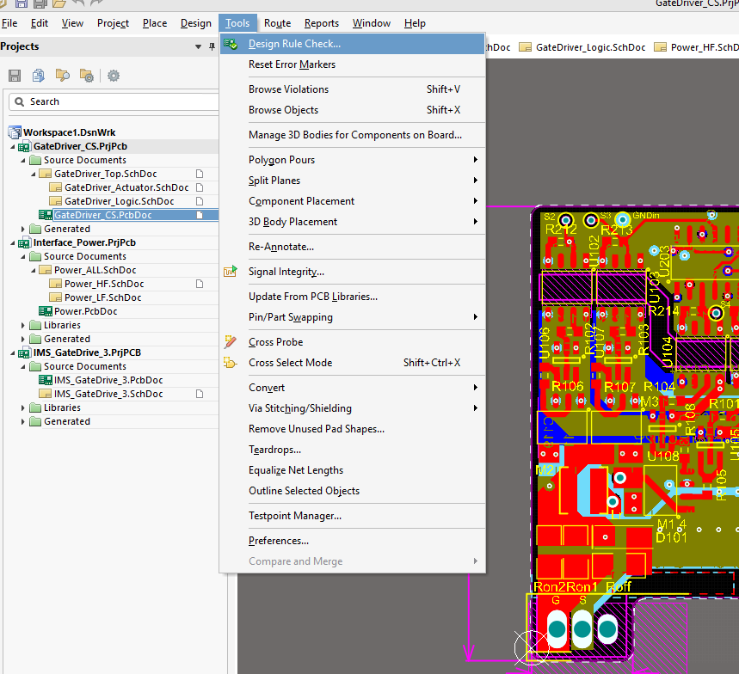

2.1 File -> Fabrication Outputs -> Gerber Files
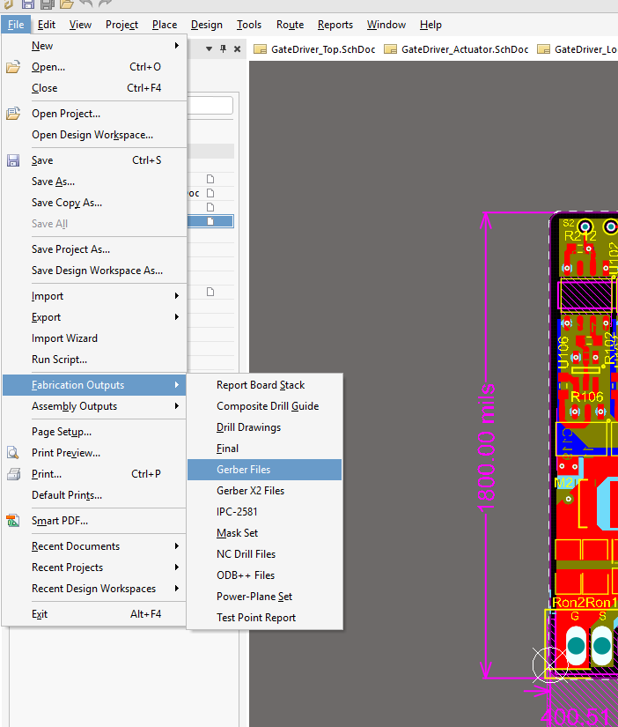

2.2 Gerber Setup -> General, Advanced
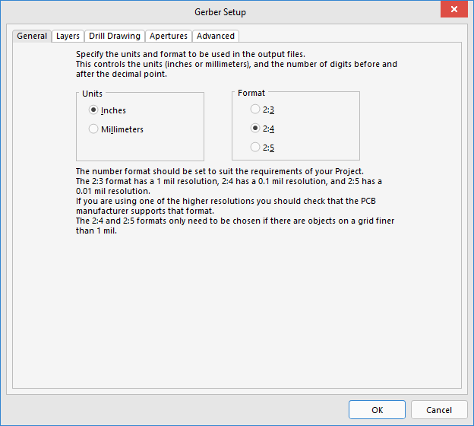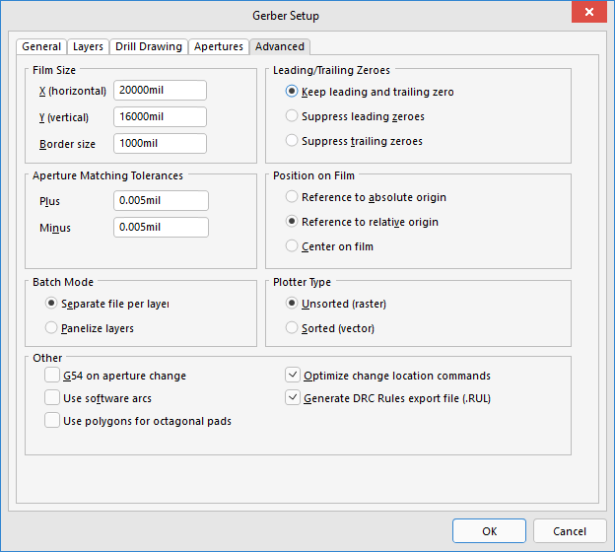

2.3 Gerber Setup -> Layers
1) Draw the board outline in “Mechanical 1” or “Top Solder Mask” layer of your PCB. Do not draw the outline in “Keep Out Layer”.
2) Select Overlay, Solder, Mechanical 1 and all signal layers (in total layer number+5). Two-layer boards should have 7 selected while four-layer boards should have 9 selected.
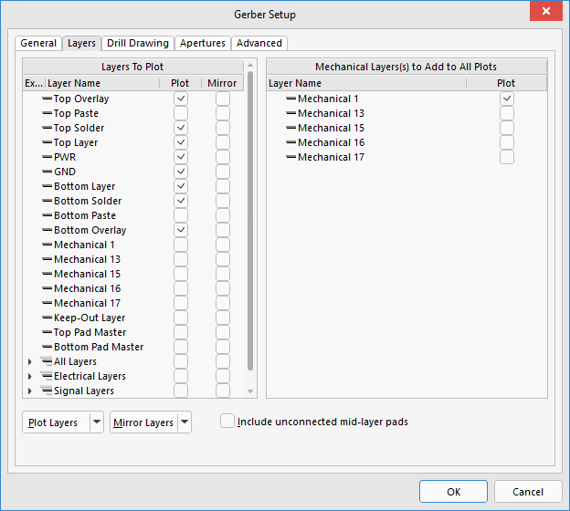

3.1 File -> Fabrication Outputs -> NC Drill Files
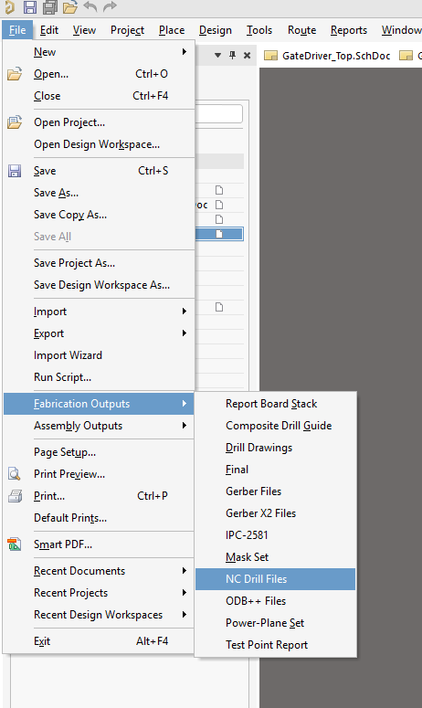

3.2 NC Drill Setup
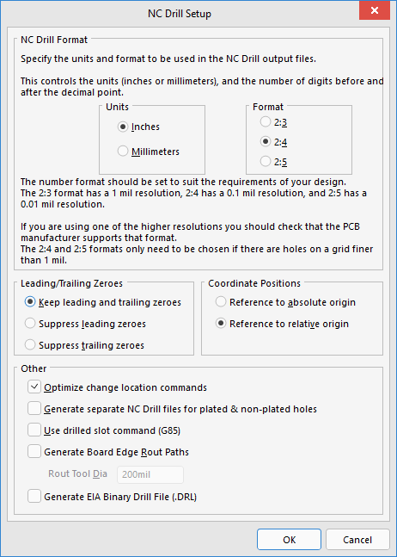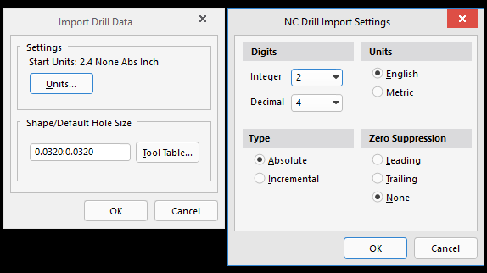

4. Go to folder “Project Outputs for Filename”, the output files are inside. Save the folder as a .zip file.
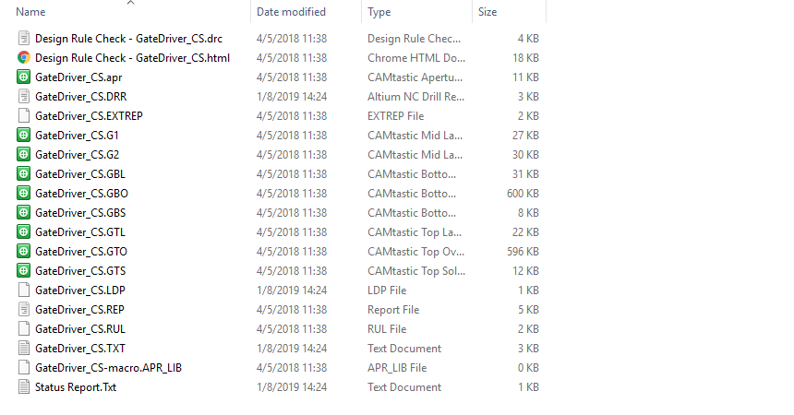

5.1 Go to Sierra website (https://www.protoexpress.com/), select “NO TOUCH” service.

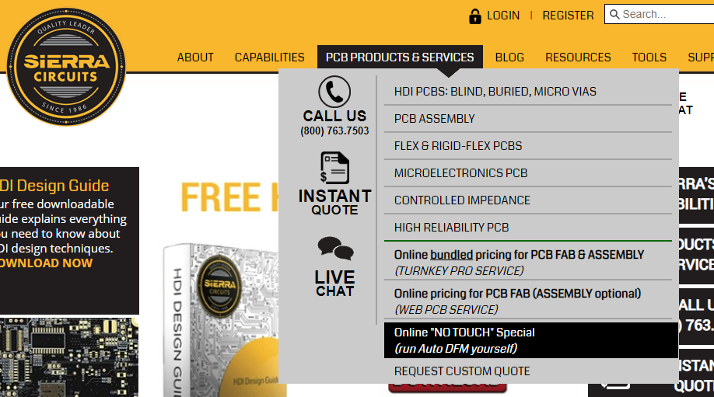

5.2 Select “QUOTE/ORDER No Touch PCBs”
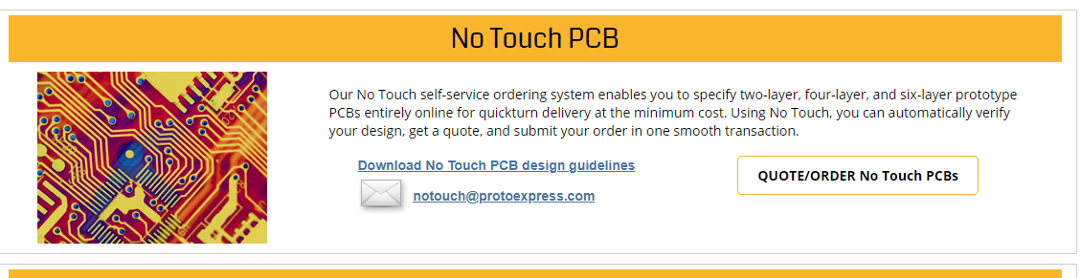

5.3 Input requirement of your PCB. Pay attention to the minimum hole size and trace/space. Your actual design shall not be lower than the number you select. Otherwise, the design cannot pass the auto check.
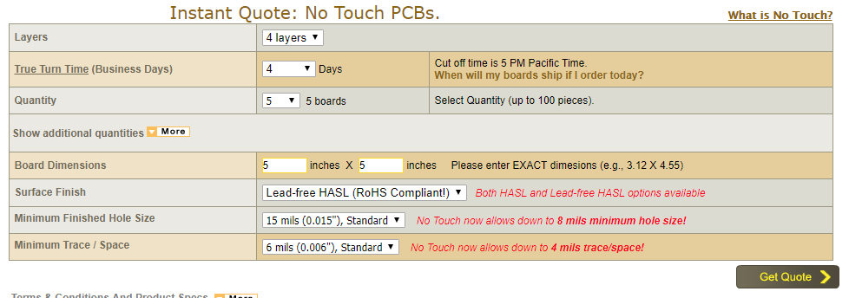

5.4 Upload the .zip file you created with all the output files inside
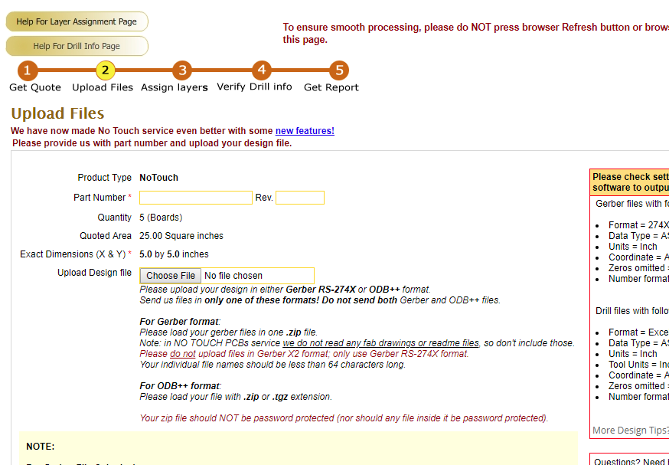

5.5 Fill the list of layer information as follows
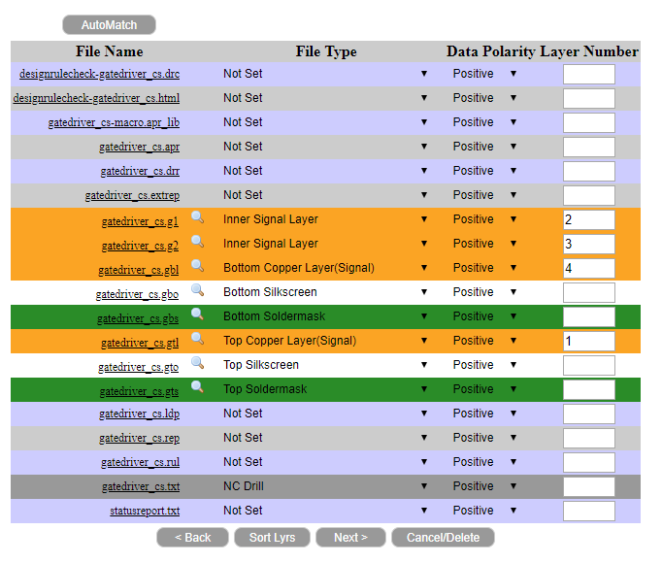

5.6 Check the hole size information and submit.
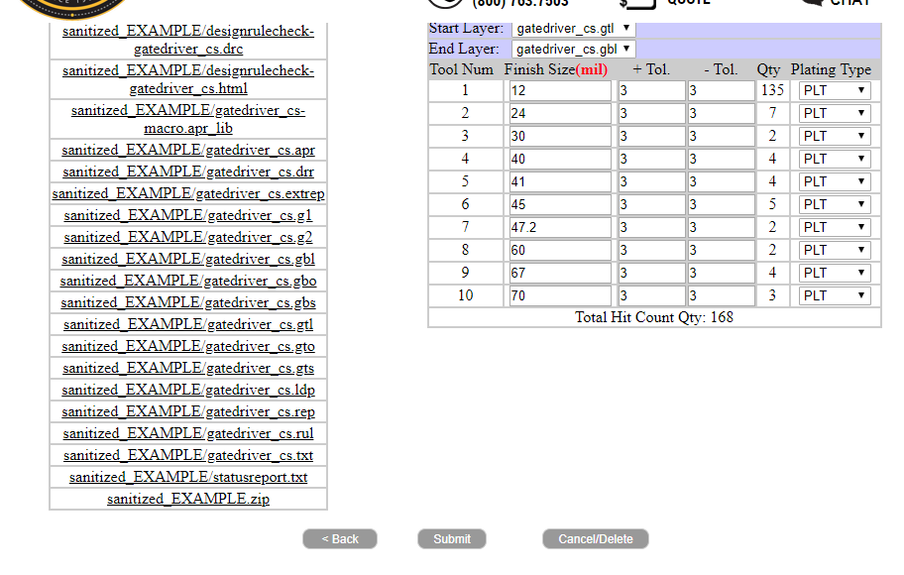

6. Sierra will run auto check for the uploaded design and you will get a notification email after it finishes. It could take more than half an hour to get the email. You can also check the status in “View Auto File Verification status” in your customer portal.
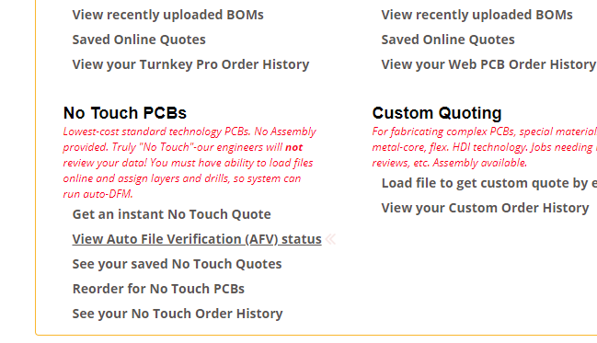

7. If issues are found in the notification email, you will need to read the report, modify your board and upload again.
