How to Place Order for Components and PCBs
By Lab Committee
Aug. 2018

Digikey
1) Use UT email address to create account and log in.
2) Find components and add them to a cart.
3) In the cart, take down Web ID and Access ID, click Cart Share and copy the link.
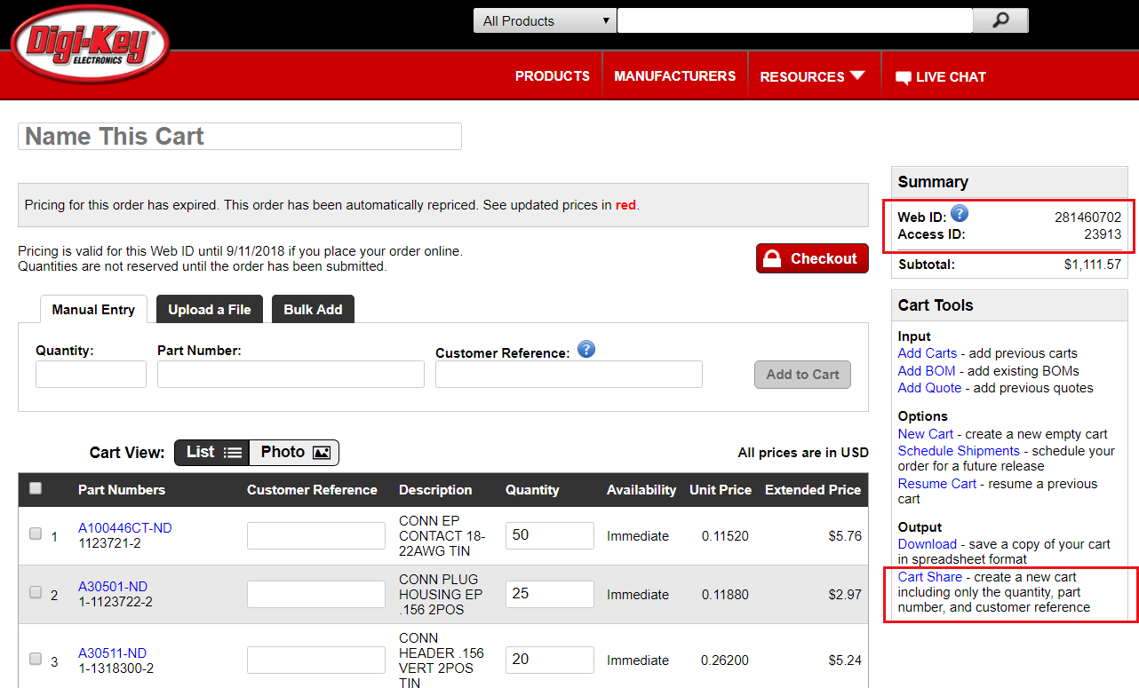
4) Write an email and send Web ID, Access ID and the link to professor and Bob for approval and order placement.

Mouser
1) Find components and add them to a cart.
2) In your cart, click Share and copy the link.
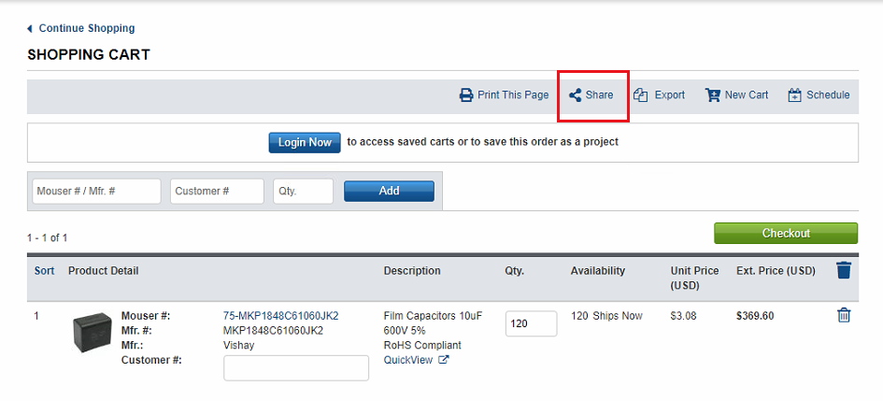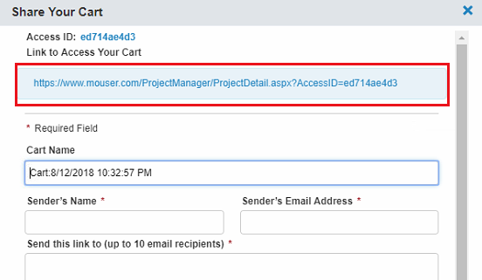
3) Write an email to Audrey.Nelson@mouser.com (Audrey Nelson) to ask for an updated quote with the link attached. For example:
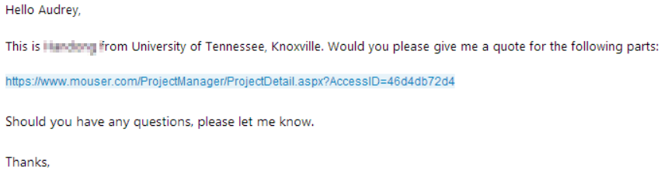
4) Later, Audrey will send you an email with the updated quote. Send the quote to professor and Bob for approval and order placement.

Newark
1) Use UT email address to create account and log in.
2) Find components and add them to a cart.
3) In your cart, click Email Cart. You must first log in, otherwise the button does not show up.
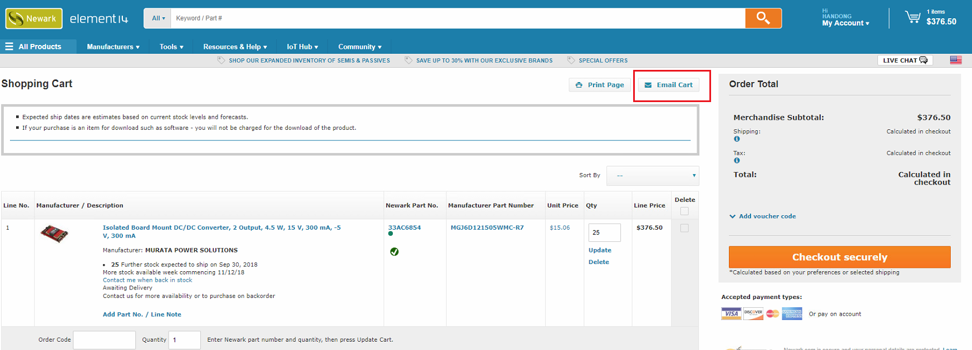
4) Send the cart to trutherford@newark.com (Traci F. Rutherford) to ask for an updated quote.
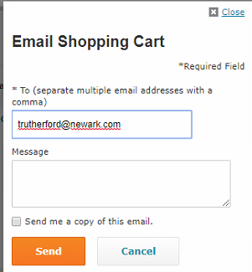
5) Later, Traci will send you an email with the updated quote. Send the quote to professor and Bob for approval and order placement.

McMaster-Carr
1) Find parts and add them to an order.
2) In the order, click Send and send the order to Bob. (rmarti47@utk.edu)
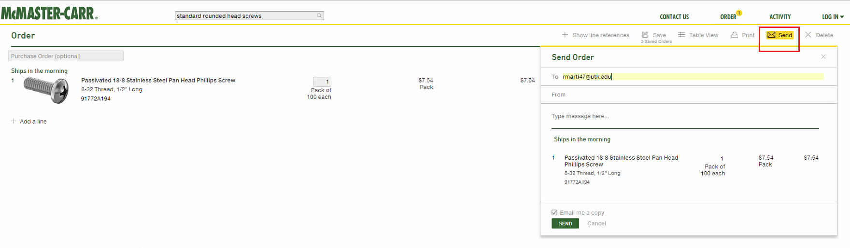
3) Send another email to professor and Bob for approval and order placement.

MSC Industrial Supply
1) Use UT email address to create account and log in.
2) Find parts and add them to a cart.
3) Print the cart to PDF and email to professor and Bob for approval and order placement. In the email, provide comma or tab delimited list with MSC part number first & quantity second to order requested parts.

Sierra Circuits
1) Use UT email address to create account and log in.
2) Upload your PCB file to Sierra Circuits for online check. For more detailed uploading tutorial, please refer “Send PCB to Sierra Circuits” in student tutorial.
3) Write an email and send your Member ID, Password and the AFV number to professor and Bob for approval and order placement.

