Introduction to the Fundamental Engineering Exam
Introduction
The Fundamentals of Engineering (FE) exam is generally your first step in the process to becoming a professional licensed engineer (P.E.). It is designed for recent graduates and students who are close to finishing an undergraduate engineering degree from an EAC/ABET-accredited program.
Structure
The FE exam is a computer-based exam. The FE exam includes a total of 110 multiple-choice questions, dividing evenly into 2 consecutive sessions, meaning each session has 55 questions. During the second session, you will not be able to view or change your answers in the first session. The exam includes topics listed below:
- Mathematics
- Probability and Statistics
- Ethics and Professional Practice
- Engineering Economics
- Properties of Electrical Materials
- Engineering Sciences
- Circuit Analysis (DC and AC Steady State)
- Linear Systems
- Signal Processing
- Electronics
- Power
- Electromagnetics
- Control Systems
- Communications
- Computer Networks
- Digital Systems
- Computer Systems
- Software Development
You can find more details about subtopics here. Please keep in mind that questions on the exam do not appear in this particular topic order, meaning they will appear randomly.
Exam Duration
You have 5 hours and 20 minutes to answer all 110 questions. You also have extra 8 minutes to go through the tutorial at the beginning of the exam and 25-minute break between 2 sessions. You can choose not to take the break. Keep in mind that you cannot work through the break.

Accessibility
During the exam, you will have access to the electronic handbook reference on the computer, which contains all the essential equations and definitions you might need. It also has a search tool helping you find the information faster. You can download the free copy of the handbook from your NCEES account.
You will be given a small white board, so you don’t have to bring sketch papers, pencils or erasers to the test center. You can also borrow a locker to keep your belongings while you’re taking the exam.
You’re allowed to bring your own scientific calculator or use the on-screen calculator. This is the list of calculator models you can bring to the exam room:
- Casio: All fx-115 and fx-991 models (Any Casio calculator must have “fx-115” or “fx-991” in its model name.)
- Hewlett Packard: The HP 33s and HP 35s models, but no others
- Texas Instruments: All TI-30X and TI-36X models (Any Texas Instruments calculator must have “TI-30X” or “TI-36X” in its model name.)
You can get the most updated list here
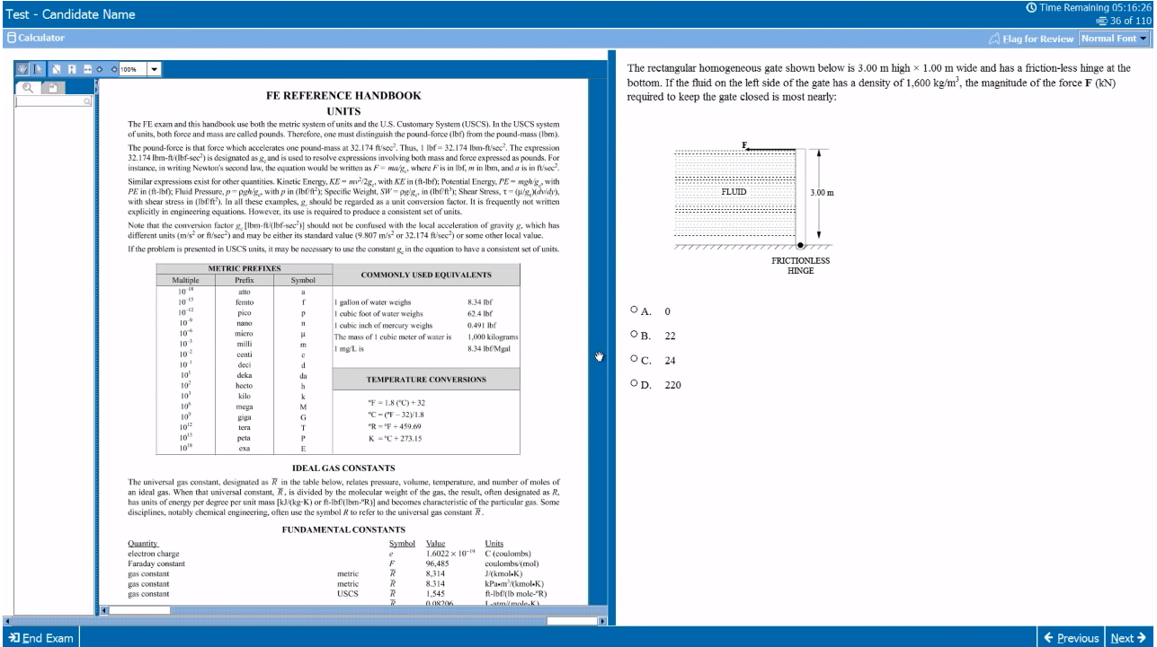
Figure 1: An example of your computer screen during the exam
Passing Score
NCEES does not announce the minimum required passing score. It constantly changes based on the average score of everyone taking the exam on the same day. However, some sources estimate it to be around 50%.
The test result does not tell you the score either. It only lets you know either you passed or failed.
Location and Time
You can take the exam year-round at NCEES-approved Pearson VUE test centers. Since you are here in Knoxville, this is the map to the closest Pearson test center.
Fee and Reimbursement
The exam fee is $175. The good news is that UT reimburses $150 for UT grad students and undergrad students who will enroll in UT grad programs. Please send your receipt to klowe@utk.edu and ask for more details.
Registration
You have to create your own MyNCEES account and follow the instruction on the screen. Then you will be able to pay the exam fee and pick the date.
Tips
- Scores are based on the total number of questions answered correctly, with no deductions made for questions answered incorrectly. Therefore, don’t leave any questions blank, i.e. try to answer them all even you don’t know the answer.
- The system will give you a break after you complete the first session (containing 55 questions). Therefore, you can divide your time between two sessions any way you like. It’s wise to complete the first session within 2 hours 40 minutes so that you will have enough time for the second session.
- For international students, when you go to the test center, make sure to bring your passport with you because they may ask for it.
- Use the flag tool on the exam window. When you encounter a tough question and you’re uncertain about the answer, instead of wasting your time thinking, you can choose the most favorable answer and flag that question. This practice saves you a lot of time for easier questions. You can always review your flagged questions before you submit that session.
- Familiarize yourself with the exam structure by doing the practice exams provided by the NCEES. You can purchase the electronic practice exam from this website. I recommend you complete at least one practice exam before taking the actual test.

